AUTOMATIC STREET LIGHTS

In this project, we're going to build an affordable solution for street light with a relay module, a photoresistor, and an Arduino.

Light only turns on when it's dark and when movement is detected. If there is light then the lights won't light up even there is motion.

Here are the main features of this project:

1: the lamp turns on when it's dark and movement is detected.

2: when movement is detected the lamp stays on for dynamic seconds.

3: when the lamp is on and detects movement, it starts counting.

4: when there's light, the lamp is turned off, even when motion is detected.

Hardware required

1: Arduino UNO

2: PIR Motion Sensor

3: Photoresistor

4: 10kOhm resistor

5: Relay module

6: Lamp cord set

7: Breadboard

8: Jumper wires

Schematics

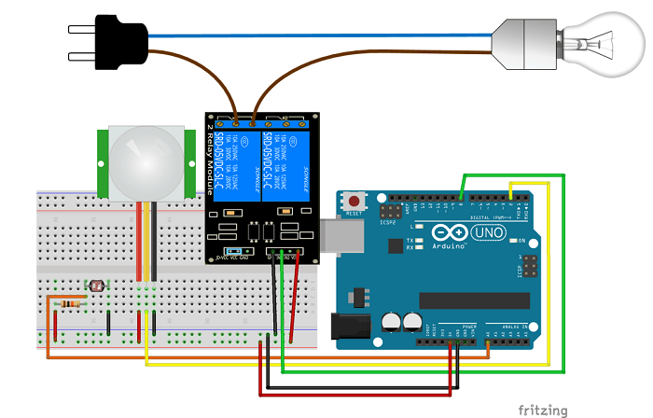

FUTURE DEVELOPMENT

We can make a PCB of it for simpler purpose and can use atTiny85 and also can use ultrasonic sensor instead of PIR sensor and this way its small form factor running the same code.